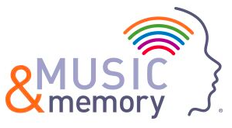

## Music & Memory at [School Name] Code of Conduct

As a member of Music & Memory at [School Name], I agree to:

* Demonstrate professional and respectful behavior, recognizing the commitment and responsibility of my role as a volunteer for a Music & Memory program.
* Follow safe workplace practices, including utilizing appropriate personal safety and hygiene standards, and reporting accidents, injuries, and unsafe situations.
* Accept assignments, guidance and feedback from Music & Memory program staff.
* Treat all Music & Memory program staff and participants with dignity and respect.
* Avoid profane and abusive language.
* Respect confidential information. Music & Memory at [School Name] are responsible for maintaining the confidentiality of all proprietary or privileged information to which they are exposed while serving as a volunteer.
* Abstain from taking photos, capturing audio or video while volunteering unless directed by Music & Memory program staff.
* Not use, possess, or be under the influence of alcohol or illegal drugs while volunteering
* Wear work appropriate clothing and the required identification. All items of clothing must be suitable for the work environment and should not contain offensive or objectionable material.
* Adhere to the procedures set forth by the Music & Memory program and/or Music & Memory at [School Name]. Failure to do so or failure to satisfactorily perform my volunteer assignment may result in my dismissal.
* Comply with Music & Memory brand standards and only use Music & Memory documents and resources for their intended purposes

With my signature, I affirm that I have read, understand, and agree to abide by Music & Memory’s *Code of Conduct*.

Name (printed):___________________________________________

Signature: ___________________________________________

Date: ___________________________________________